DEEP LEARNING APPROACH FOR

CARDIOVASCULAR DISEASE DIAGNOSIS USING

ANN BASED MULTILAYER PERCEPTRON METHOD

PROJECT REPORT

Submitted in partial fulfillment of the requirements for the award of the degree of

BACHELOR OF TECHNOLOGY
in

COMPUTER SCIENCE AND ENGINEERING

Submitted by

NALLABOTHULA.  SUMITH VENKAT  Roll No. 21731A0533 |  | SHAIK.  KARISHMA  Roll No. 21731A0553
LAKKU.  HEMA LATHA  Roll No. 21731A0526 |  | CHINTHA.  JOSHITHA  Roll No. 21731A0514

Under The Guidance of

Mr. P. VENKATESWARA REDDY

Assistant Professor


DEPARTMENT OF

COMPUTER SCIENCE AND ENGINEERING

PBR VISVODAYA INSTITUE OF TECHNOLOGY & SCIENCE

(AUTONOMOUS)
KAVALI-524201, NELLORE DISTRICT, AP

Jawaharlal Nehru Technological University, Ananthapuramu, AP, India

APRIL 2025

PBR VISVODAYA INSTITUTE OF TECHNOLGY & SCIENCE

(AUTONOMOUS)
KAVALI

BONAFIDE CERTIFICATE

Certified that this project report “DEEP LEARNING APPROACH FOR CARDIOVASCULAR DISEASE DIAGNOSIS USING ANN BASED MULTI LAYER PERCEPTRON” is the bonafide work done by “N. SUMITH VENKAT (21731A0533), SK. KARISHMA (21731A0553), L. HEMA LATHA (21731A0526), CH. JOSHITHA (21731A0526)”, who carried out the project under my guidance during the year 2024-25, towards partial fulfillment of the requirements of the Degree of Bachelor of Technology in Computer Science and Engineering, from Jawaharlal Nehru Technological University, Anantapur. The results embodied in this report have not been submitted to any other University for the award of any degree.

Mr. P. Venkateswara Reddy  PROJECT SUPERVISOR  Department of CSE |  | Dr. D Srujan Chandra Reddy  HEAD OF THE DEPARTMENT  Department of CSE

External Viva Voce conducted on ___________________

INTERNAL EXAMINER |  | EXTERNAL EXAMINER

PBR VISVODAYA INSTITUTE OF TECHNOLGY & SCIENCE
KAVALI

CERTIFICATEOFAUTHENTICATION

We solemnly declare that this project report, “DEEP LEARNING APPROACH FOR CARDIOVASCULAR DISEASE DIAGNOSIS USING ANN BASED MULTI LAYER PERCEPTRON METHOD” is our original work, carried out under the supervision of Mr. P. VENKATESWARA REDDY, Assistant Professor, in partial fulfillment of the requirements for the Bachelor of Technology (B.Tech.) degree in Computer Science and Engineering from Jawaharlal Nehru Technological University, Anantapur, during the academic year 2024-25.

Furthermore, we certify that this work has not been submitted, either in part or in full, to any other department of Jawaharlal Nehru Technological University or any other university, institution, or elsewhere, nor has it been published in any form.

Signature of the Students

DATE:
1. N. SUMITH VENKAT (21731A0533)

2. SK. KARISHMA (21731A0553)

3. L. HEMA LATHA (21731A0526)

4. CH. JOSHITHA (21731A0514)

AC

KNOWLEDGEMENT

We extend our heartfelt gratitude to PBR VISVODAYA INSTITUTE OF TECHNOLOGY & SCIENCE, KAVALI, for providing us with the opportunity to complete this project report.

We express our deep appreciation and indebtedness to our esteemed Chairman, Mr. D. VIDYADHARA KUMAR REDDY, Academic Director Dr. D. PRATHYUSHA REDDI and Academic In-Charge Dr. D. LIKHITH REDDY, for fostering an excellent academic environment..

It is our privilege to convey our sincere gratitude to our Director, Wg. Cdr. I.P.C. Reddy (Retd.), and Principal, Dr. N. SESHAIAH, for granting us this opportunity to successfully complete our project report.

We are profoundly grateful to our Head of the Department, Dr. D Srujan Chandra Reddy, Head & Professor, Department of Computer Science and Engineering, for his invaluable support, essential facilities, guidance, and unwavering encouragement, which played a crucial role in the timely completion of this project.

A special note of appreciation goes to our dedicated guide, Mr. P. VENKATESWARA REDDY, Assistant Professor, for his inspiring mentorship, continuous encouragement, and insightful guidance throughout this project.

Lastly, we express our sincere gratitude to all our lecturers, lab coordinators, non-teaching staff, and friends who directly or indirectly contributed to the successful completion of this project, offering valuable suggestions and support at every step.

ABSTRACT

A smart helmet is a type of protective headgear used by the rider which makes bike driving safer than before. We live in a world where the rules of the road have no importance for people and they are regularly violated. In addition, its human nature to resist what is imposed on them. Thus, using a different perspective, we provide safety with luxurious and intelligent features using a smart helmet. The main purpose of this helmet is to provide safety for the rider. This can be implemented by using advanced features like alcohol detection, accident identification, location tracking, use as a hands-free device, fall detection. This makes it not only a smart helmet but also a feature of a smart bike. It is compulsory to wear the helmet, without which the ignition switch cannot turn on. A radio frequency module is responsible for the wireless communication between the helmet and the bike circuit .The alcho - lock function is used to prevent drink and drive scenarios by locking ignition. Accelerometer detects accidents, in case of an accident, it will send a message through GSM along with location with the help of GPS module to one personal contact and one concerned authority that the person has been into an accident.

Keywords:- Heart Disease Prediction , Artificial Neural Network (ANN) , Machin
Learning , Early Detection , Healthcare AI , Cleveland Heart Disease Dataset , Data Preprocessing , Model Training & Testing , Predictive Analytics , Medical Diagnosis

TABLE OF CONTENTS
CHAPTER NO. |  | TITLE |  | PAGE NO.
 |  | List of tables |  | i
 |  | List of figures |  | ii
1 |  | Introduction
 | 1.1 | Introduction to the project |  | 2
 | 1.2 | Objectives |  | 3
 | 1.3 | Existing System |  | 3
 |  | 1.3.1 Disadvantages of the Existing System |  | 3
 | 1.4 | Proposed System |  | 4
 |  | 1.4.1 Advantages of Proposed System |  | 5
2 |  | System Analysis
 | 2.1 | Feasibility study
 |  | 2.1.1 Economical Feasibility |  | 7
 |  | 2.1.2 Technical Feasibility |  | 7
 |  | 2.1.3 Social Feasibility |  | 8
 | 2.2 | System Requirement Specification
 |  | 2.2.1 Functional Requirements |  | 8
 |  | 2.2.2 Non-Functional Requirements |  | 10
 | 2.3 | Input and Output Design
 |  | 2.3.1 Input Design |  | 11
 |  | 2.3.2 Output Design |  | 12
 | 2.4 | Software Development Life Cycle
 |  | 3 System Design
 | 3.1 | System Architecture |  | 14
 | 3.2 | Module Description |  | 14
 | 3.3 | UML Diagrams
 |  | 3.3.1 Use Case Diagram |  | 22
 |  | 3.3.2 Class Diagram |  | 23
 |  | 3.3.3 Sequence Diagram |  | 24
 |  | 3.3.4 Activity Diagram |  | 24
4 |  | System Implementation
 | 4.1 | Software Environment |  | 29
 |  | 4.1.1 Python |  | 29
 | 4.2 | Create a Project |  | 36
 | 4.3 | Source code |  | 39
 | 4.4 | Output Screens |  | 47
5 |  | System Testing
 | 5.1 | Types of Testing |  | 56
6 |  | Conclusion & Future Enhancement
 | 6.1 | Conclusion |  | 60
7 |  | References |  | 63

List of Figures
Figure No. |  | Figure Description |  | Page No.
3.1 |  | System Architecture |  | 14
3.2.1 |  | Use case diagram |  | 23
3.2.2 |  | Class diagram |  | 23
3.2.3 |  | Sequence diagram |  | 24
3.2.4 |  | Activity diagram |  | 25

LIST OF SCREENS

S.NO | SCREEN NO | SCREEN NAME | PAGE NO
01 | 4.4.1 | Home page | 47
02 | 4.4.2 | Upload Dataset | 48
03 | 4.4.3 | Dataset | 48
04 | 4.4.4 | Preprocess Dataset | 49
05 | 4.4.5 | Dataset processed | 49
06 | 4.4.6 | Build CNN Model | 50
07 | 4.4.7 | Disease Predicted as Pneumonia Viral | 52

CHAPTER 1

INTRODUCTION

Chapter:1 INTRODUCTION

  - INTRODUCTION TO PROJECT
Coronary illness is a significant general wellbeing concern, influencing a large number of individuals around the world. It is the main source of death in numerous nations, including the US. Early discovery of coronary illness is basic for successful treatment and the executives, yet current diagnostic strategies are frequently expensive, time-consuming, and require specific hardware and expertise.

AI methods can help with the early discovery of coronary illness by precisely anticipating the probability of the sickness in patients in light of their clinical history and other pertinent variables. Among these procedures, Counterfeit Brain Organizations (ANNs) have exhibited high precision in forecasting the probability of coronary illness.

This task aims to foster an ANN model that can precisely foresee the probability of coronary illness in patients in view of a bunch of clinical highlights. Using a large dataset of patient data, the model will be trained and tested, and its accuracy and performance will be evaluated.

This venture means to furnish medical services experts with a solid and open device for anticipating the probability of coronary illness in patients. Improved patient outcomes and better resource management in the healthcare system can result from the developed model's potential to aid in the early detection and treatment of heart disease.
The rest of this report is coordinated as follows: the accompanying segment will give an outline of related work in the field of coronary illness prediction utilizing AI methods. The ensuring segments will portray the philosophy and execution of the undertaking, including the dataset readiness, the advancement of the ANN model, and the assessment of the model’s presentation. The findings will be summarized, and potential project enhancements will be highlighted in the conclusion.

1.2 OBJECTIVE
This project aims to develop an Artificial Neural Network (ANN)-based heart disease prediction system that can accurately assess the likelihood of heart disease in patients using medical data. By leveraging machine learning techniques and the Cleveland Heart Disease dataset, the system aims to enhance early detection, improve diagnostic accuracy, and assist healthcare professionals in making informed decisions. The project also focuses on creating a user-friendly interface for easy data input and result interpretation, ultimately contributing to AI-driven advancements in healthcare and improving patient outcomes

1.3 EXISTING SYSTEM:

The existing system demonstrates the prediction of heart disease using multiple machine learning classification algorithms such as Naive Bayes, Random Forest, SVM etc., and compares their accuracy scores.
The existing system for predicting heart disease uses Naive Bayes, Random Forest, and Support Vector Machines (SVM). These algorithms are commonly used in machine learning for classification tasks. The system collects patient data, such as age, gender, blood pressure, and cholesterol levels, and applies these algorithms to predict the likelihood of heart disease. While these algorithms have been successful in some cases, they have certain limitations that can impact their accuracy and effectiveness.
The existing system developed a heart disease algorithm based on Ensemble Learning Technique, known as Stacking Classifier, where different classification models will be developed and trained with the training set's help to compare their performance by using their accuracy scores. Later, the Stacking Ensemble Learning method will also be used to boost the performance of the base classification models.

DISADVANTAGES:
Overfitting: Ensemble learning techniques can sometimes overfit the training data, resulting in high accuracy on the training data but poor performance on new, unseen data. This can lead to incorrect predictions and compromised patient outcomes.
Limited Interpretability: Ensemble learning techniques can be complex and difficult to interpret, making it challenging to understand the underlying factors that contribute to heart disease prediction. This can limit the ability of clinicians and healthcare professionals to use the model in decision-making processes.
Data Bias: Ensemble learning techniques can be sensitive to data bias, where the model is trained on imbalanced datasets, leading to biased predictions. This can affect the accuracy and reliability of the predictions.
Computationally Expensive: Ensemble learning techniques can be computationally expensive and require significant computational resources to train and optimize. This can limit their use in resource-constrained environments, where access to high-performance computing resources may be limited.
Need for Expertise: Ensemble learning techniques require expertise in data science and machine learning to develop and optimize, limiting their accessibility to non-experts in the field.

1.4 PROPOSED SYSTEM:
In the proposed system we develop Heart Disease Prediction using Machine Learning particularly using Artificial Neural Network (ANN). The proposed system involves developing a predictive model using ANN that can accurately identify patients at risk of heart disease. The system uses the popular dataset Cleveland Heart Disease dataset available on UCI machine learning repository / Kaggle, and applies ANNs to predict the likelihood of heart disease. ANNs can learn from large datasets and can handle noisy and complex data, making them an ideal choice for medical diagnosis. In the proposed system, developing an ANN model that can learn from the preprocessed data and accurately predict the likelihood of heart disease in patients. An ANN also called as neural network is a mathematical model based on biological neural networks. Artificial neural network is based on observation of a human brain. Human brain is very complicated web of neurons. Neuron has axons, dendrites and synapses. The designed ANN has three layers: namely an input layer, a hidden layer and an output layer. The proposed system is developed using Flask web framework where the trained ANN model is deployed as a web application so that any user or healthcare professional, patients can be accessed to predict the likelihood of heart disease.

1.4.1 ADVANTAGES OF PROPOSED SYSTEM

Early Detection: The ANN-based predictive model can detect heart disease in its early stages, enabling early interventions, and potentially saving lives.
Accuracy: ANNs can learn from large datasets and can identify complex patterns and relationships in the data, leading to more accurate predictions of heart disease.
Speed: The ANN-based predictive model can process data quickly, providing rapid results that can be used for timely interventions and treatment.
Customizability: The ANN-based predictive model can be customized based on patient characteristics, such as age, gender, and medical history, leading to more personalized predictions and better outcomes.
Scalability: The ANN-based predictive model can be scaled up to analyze large datasets, enabling population-level analysis and identification of risk factors for heart disease.
Reduced Costs: Early detection of heart disease through the ANN-based predictive model can reduce healthcare costs associated with more severe forms of heart disease.

CHAPTER 2
SYSTEM ANALYSIS

Chapter: 2 SYSTEM ANALYSIS
2.1 FEASIBILITY STUDY

The feasibility of the project is analyzed in this phase and business proposal is put forth with a very general plan for the project and some cost estimates. During system analysis the feasibility study of the proposed system is to be carried out. This is to ensure that the proposed system is not a burden to the company. For feasibility analysis, some understanding of the major requirements for the system.

Three key considerations involved in the feasibility analysis are
- ECONOMICAL FEASIBILITY
- TECHNICAL FEASIBILITY
- SOCIAL FEASIBILITY

2.1.1 ECONOMICAL FEASIBILITY:

This study is carried out to check the economic impact that the system will have on the organization. The amount of fund that the company can pour into the research and development of the system is limited. The expenditures must be justified. Thus the developed system as well within the budget and this was achieved because most of the technologies used are freely available. Only the customized products had to be purchased.

2.1.2 TECHNICAL FEASIBILITY:

This study is carried out to check the technical feasibility, that is, the technical requirements of the system. Any system developed must not have a high demand on the available technical resources. This will lead to high demands on the available technical resources. This will lead to high demands being placed on the client. The developed system must have a modest requirement, as only minimal or null changes are required for implementing this system.

2.1.3 SOCIAL FEASIBILITY:

The aspect of study is to check the level of acceptance of the system by the user. This includes the process of training the user to use the system efficiently. The user must not feel threatened by the system, instead must accept it as a necessity. The level of acceptance by the users solely depends on the methods that are employed to educate the user about the system and to make him familiar with it. His level of confidence must be raised so that he is also able to make some constructive criticism, which is welcomed, as he is the final user of the system.

2.2 SYSTEM REQUIREMENT SPECIFICATION
2.2.1 FUNCTIONAL REQUIREMENTS

Sure, here are some functional requirements for developing a deep learning model for predicting brain strokes:
Data Collection and Preprocessing:
The system should be capable of collecting a diverse dataset of brain images, such as MRI or CT scans, along with relevant patient information like age, gender, medical history, etc.
It should preprocess the collected data to ensure consistency, remove noise, and standardize the format for input to the deep learning model.
Feature Extraction:
Implement algorithms or techniques to extract relevant features from the brain images and patient data that could be indicative of stroke risk.
These features might include characteristics like lesion location, size, shape, intensity, as well as demographic and clinical data.
Model Development:
Design and implement deep learning architectures suitable for analyzing medical images and patient data.
Experiment with various model architectures like convolutional neural networks (CNNs), recurrent neural networks (RNNs), or their combinations to identify the most effective approach.
Train the model using a portion of the collected data while reserving another portion for validation and testing.
Prediction Functionality:
Develop the functionality to input new patient data and/or brain images into the trained model to predict the likelihood of a stroke occurrence.
Ensure that the system provides interpretable outputs, such as a probability score or risk assessment, along with explanations for the predictions if possible.
Integration with Healthcare Systems:
Integrate the developed model into existing healthcare systems or develop a standalone application/interface for healthcare professionals to access and utilize the stroke prediction functionality.
Ensure compliance with relevant healthcare data privacy regulations like HIPAA (Health Insurance Portability and Accountability Act) for handling patient data.
Real-time Monitoring and Alerts:
Optionally, develop features for real-time monitoring of patients at risk of stroke based on continuous data streams such as vital signs or wearable device data.
Implement alert mechanisms to notify healthcare providers when the model detects an increased risk of stroke for a patient.
Model Evaluation and Maintenance:
Implement mechanisms to regularly evaluate the performance of the deployed model using new data and update it if necessary to maintain accuracy and reliability.
Provide tools for monitoring model performance metrics, such as accuracy, sensitivity, specificity, and area under the curve (AUC), over time.
User Management and Authentication:
Implement user management functionality with role-based access control to ensure that only authorized personnel can access patient data and use the prediction system.
Incorporate authentication mechanisms to verify the identity of users accessing the system.
Documentation and Support:
Provide comprehensive documentation for users, including instructions on how to use the system, interpret results, and troubleshoot issues.
Offer technical support and assistance to healthcare professionals using the system, including training if necessary.
Scalability and Performance:
Design the system to be scalable, allowing it to handle an increasing volume of patient data and user requests as the usage grows.
Optimize the performance of the system to ensure fast response times, particularly for real-time prediction and monitoring functionalities.

2.2.2 NON-FUNCTIONAL REQUIREMENTS

Non-functional requirements are constraints or qualities that specify how a system should behave, rather than what functions it should perform. When developing a deep learning (DL) model for predicting brain strokes, several non-functional requirements should be considered:
Performance: The model should achieve high accuracy, sensitivity, and specificity in predicting strokes to ensure its effectiveness in clinical settings.
Scalability: The system should be able to handle varying workloads and data volumes, accommodating potential increases in usage over time.
Response Time: The prediction process should be efficient, with low latency, to provide timely results for healthcare professionals.
Robustness: The model should be resilient to noise, outliers, and variations in input data, ensuring consistent performance across different scenarios.
Interpretability: The model's predictions should be interpretable and explainable to healthcare professionals, allowing them to understand the factors contributing to each prediction.
Security and Privacy: Measures should be in place to protect patient data and ensure compliance with regulations such as HIPAA (Health Insurance Portability and Accountability Act) to maintain confidentiality and integrity.
Maintainability: The system should be designed for ease of maintenance, including updates to the model and integration with new data sources or technologies.
Compatibility: The system should be compatible with existing healthcare IT infrastructure and standards to facilitate integration and interoperability.
Usability: The user interface (if applicable) should be intuitive and user-friendly, catering to the needs of healthcare professionals with varying levels of technical expertise.
Ethical Considerations: The system should adhere to ethical guidelines, including fairness, transparency, and accountability in its decision-making process.
By addressing these non-functional requirements, developers can ensure that the DL model for brain stroke prediction is not only accurate but also reliable, efficient, and user-friendly in real-world healthcare settings.

2.3 INPUT AND OUTPUT DESIGN
2.3.1 INPUT DESIGN

The input design is the link between the information system and the user. It comprises the developing specification and procedures for data preparation and those steps are necessary to put transaction data in to a usable form for processing can be achieved by inspecting the computer to read data from a written or printed document or it can occur by having people keying the data directly into the system. The design of input focuses on controlling the amount of input required, controlling the errors, avoiding delay, avoiding extra steps and keeping the process simple. The input is designed in such a way so that it provides security and ease of use with retaining the privacy. Input Design considered the following things:
What data should be given as input?
How the data should be arranged or coded?
The dialog to guide the operating personnel in providing input.
Methods for preparing input validations and steps to follow when error occur.

OBJECTIVES

1. Input Design is the process of converting a user-oriented description of the input into a computer-based system. This design is important to avoid errors in the data input process and show the correct direction to the management for getting correct information from the computerized system.
2. It is achieved by creating user-friendly screens for the data entry to handle large volume of data. The goal of designing input is to make data entry easier and to be free from errors. The data entry screen is designed in such a way that all the data manipulates can be performed. It also provides record viewing facilities.
3. When the data is entered it will check for its validity. Data can be entered with the help of screens. Appropriate messages are provided as when needed so that the user will not be in maize of instant. Thus the objective of input design is to create an input layout that is easy to follow
2.3.2 OUTPUT DESIGN
A quality output is one, which meets the requirements of the end user and presents the information clearly. In any system results of processing are communicated to the users and to other system through outputs. In output design it is determined how the information is to be displaced for immediate need and also the hard copy output. It is the most important and direct source information to the user. Efficient and intelligent output design improves the system’s relationship to help user decision-making.
1. Designing computer output should proceed in an organized, well thought out manner; the right output must be developed while ensuring that each output element is designed so that people will find the system can use easily and effectively. When analysis design computer output, they should Identify the specific output that is needed to meet the requirements.
2. Select methods for presenting information.
3. Create document, report, or other formats that contain information produced by the system.
The output form of an information system should accomplish one or more of the following objectives.
Convey information about past activities, current status or projections of the Future.
Signal important events, opportunities, problems, or warnings.
Trigger an action.
Confirm an action.

CHAPTER 3
SYSTEM DESIGN

Chapter: 3 SYSTEM DESIGN
3.1 SYSTEM ARCHITECTURE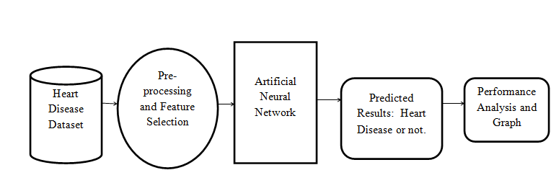

Fig No:3.1 System Architecture

Description:
For the deep learning model architecture, a Convolutional Neural Network (CNN) is commonly used for image classification tasks. The CNN architecture typically consists of convolutional layers followed by pooling layers, fully connected layers, and an output layer. The specific design of the CNN architecture, including the number of layers, filter sizes, and activation functions, can be tailored based on the dataset

3.2 MODULE DESCRIPTION:
MODULES:
- Data Collection
- Dataset
- Importing the necessary libraries
- Splitting the dataset
- Neural network
- Architecture Of ANN
- Coding Part
- Model selection
- Apply the model and plot the graphs for accuracy and loss
- Analyze and Prediction
- Accuracy on test set
- Saving the Trained Model

Data Collection:
In the first module of the Heart Disease Prediction using Machine Learning we make the data collection process. This is the first real step towards the real development of a machine learning model, collecting data. This is a critical step that will cascade in how good the model will be, the more and better data that we get; the better our model will perform.
There are several techniques to collect the data, like web scraping, manual interventions. The dataset is located in the model folder.

Dataset:

In this module, we describe about the dataset features. The dataset consists of 918 individual data. There are 14 columns in the dataset, which are described below.
Age: displays the age of the individual.
Sex: displays the gender of the individual using the following format :
1 = male
0 = female
Chest-pain type(cp): displays the type of chest-pain experienced by the individual using the following format :
1 = typical angina
2 = atypical angina
3 = non — anginal pain
4 = asymptotic
Resting Blood Pressure(trestbps): displays the resting blood pressure value of an individual in mmHg (unit)
Serum Cholestrol(chol): displays the serum cholesterol in mg/dl (unit)
Fasting Blood Sugar(fbs): compares the fasting blood sugar value of an individual with 120mg/dl.
If fasting blood sugar > 120mg/dl then : 1 (true)
else : 0 (false)
Resting ECG (restecg): displays resting electrocardiographic results
0 = normal
1 = having ST-T wave abnormality
2 = left ventricular hyperthrophy
Max heart rate achieved : displays the max heart rate achieved by an individual.
Exercise induced angina :
1 = yes
0 = no
ST depression induced by exercise relative to rest: displays the value which is an integer or float.
Peak exercise ST segment :
1 = upsloping
2 = flat
3 = downsloping
Number of major vessels (0–3) colored by flourosopy: displays the value as integer or float.
Thal : displays the thalassemia :
3 = normal
6 = fixed defect
7 = reversible defect
Diagnosis of heart disease: Displays whether the individual is suffering from heart disease or not :
0 = absence
1 = present.

Importing the necessary libraries:
This module involves importing the necessary libraries such as NumPy, Pandas, and TensorFlow to implement the ANN model. We will be using Python language for this. First we will import the necessary libraries such as keras for building the main model, sklearn for splitting the training and test data, PIL for converting the images into array of numbers and other libraries such as pandas, numpy, matplotlib and tensorflow.

Splitting the dataset:
This module involves splitting the preprocessed dataset into training and testing sets for model development and evaluation. Split the dataset into train and test. 80% train data and 20% test data.

Neural network:
This module involves developing the ANN model with multiple hidden layers, activation functions, and optimization algorithms. For classification problems, it is composed of:
A scaling layer.
A perceptron layer.
A probabilistic layer.
For the scaling layer, the minimum and maximum scaling methods are set.
We set one perceptron layer, with 3 neurons as a first guess, having the logistic activation function.
Neural Network is a series of algorithms that are trying to mimic the human brain and find the relationship between the sets of data. It is being used in various use-cases like in regression, classification, Image Recognition and many more.

Architecture of ANN

This module involves designing the architecture of the ANN model, including the number of input and output neurons, the number of hidden layers, and the activation functions. A neural network has many layers and each layer performs a specific function, and as the complexity of the model increases, the number of layers also increases that why it is known as the multi-layer perceptron.
The purest form of a neural network has three layers input layer, the hidden layer, and the output layer. The input layer picks up the input signals and transfers them to the next layer and finally, the output layer gives the final prediction and these neural networks have to be trained with some training data as well like machine learning algorithms before providing a particular problem. Now, let’s understand more about perceptron.

About Perceptron
As discussed above multi-layered perceptron these are basically the hidden or the dense layers. They are made up of many neurons and neurons are the primary unit that works together to form perceptron. In simple words, as you can see in the above picture each circle represents neurons and a vertical combination of neurons represents perceptrons which is basically a dense layer.
Now in the above picture, you can see each neuron’s detailed view. Here, each neurons have some weights (in above picture w1, w2, w3) and biases and based on this computations are done as, combination = bias + weights * input (F = w1*x1 + w2*x2 + w3*x3) and finally activation function is applied output = activation (combination) in above picture activation is sigmoid represented by 1/(1 + e-F). There are some other activation functions as well like ReLU, Leaky ReLU, tanh, and many more.
Working of ANN
At First, information is feed into the input layer which then transfers it to the hidden layers, and interconnection between these two layers assign weights to each input randomly at the initial point. And then bias is added to each input neuron and after this, the weighted sum which is a combination of weights and bias is passed through the activation function. Activation Function has the responsibility of which node to fire for feature extraction and finally output is calculated. This whole process is known as Foreward Propagation. After getting the output model to compare it with the original output and the error is known and finally, weights are updated in backward propagation to reduce the error and this process continues for a certain number of epochs (iteration). Finally, model weights get updated and prediction is done.

Coding Part
This module involves coding the ANN model using the TensorFlow library, implementing the forward and backward propagation algorithms, and optimizing the model using techniques such as dropout and batch normalization. Now let’s code and understand the concepts using it.
First Import Libraries like NumPy, pandas, and also import classes named sequential and dense from Keras library.
import numpy as np
import pandas as pd
from keras.models import Sequential
from keras.layers import Dense

Model selection:
This module involves selecting the best ANN model from a set of candidate models. Order selection is used to find the complexity of the neural network that optimizes the generalization performance. That is the number of neurons that minimize the error in the selection instances.
Input selection (or feature selection) is used to find the set of inputs that produce the best generalization. The genetic algorithm has been applied here, but it does not reduce the selection error value, so we leave all input variables.

Defining the Keras Model
Models in Keras are defined as a sequence of layers in which each layer is added one after another. The input should contain input features and is specified when creating the first layer with the input_dims argument. Here inputs_dims will be 8.
Now a question arises that how can we decide the number of layers and number of neurons in each layer?
It is quite difficult to know how many layers we should use. Generally for this Keras tuner is used, which takes a range of layers, a range of neurons, and some activation functions. and then by permutation and combination, it tries to find which is best suited. But one disadvantage of this is it takes lots of time. You can refer to the documentation of it Keras Tuner for more details.
In this example, a fully connected network with a three-layer is used which is defined using the Dense Class. The first argument takes the number of neurons in that layer and, and the activation argument takes the activation function as an input. Here ReLU is used as an activation function in the first two layers and sigmoid in the last layer as it is a binary classification problem.

Compile Keras Model
While compiling we must specify the loss function to calculate the errors, the optimizer for updating the weights and any metrics.
In this case, we will use “binary_crossentropy“ as the loss argument as it is a binary classification problem.
Here we will take optimizer as “adam“ as it automatically tunes itself and gives good results in a wide range of problems and finally we will collect and report the classification accuracy through metrics argument.
Fitting The Keras Model.
Now we will fit our model on the loaded data by calling the fit() function on the model.
The training process will run for a fixed number of iterations through the dataset which is specified using the epochs argument. The number of dataset rows should be and are updated within each epoch, and set using the batch_size argument.
Here, We will run for 100 epochs and a batch size of 25.
Evaluate Keras Model
The evaluation of the model on the dataset can be done using the evaluate() function. It takes two arguments i.e, input and output. It will generate a prediction for each input and output pair and collect scores, including the average loss and any metrics such as accuracy.
The evaluate() function will return a list with two values first one is the loss of the model and the second will be the accuracy of the model on the dataset. We are only interested in reporting the accuracy and hence we ignored the loss value.

Make Predictions
Prediction can be done by calling the predict() function on the model. Here sigmoid activation function is used on the output layer, so the predictions will be a probability in the range between 0 and 1.

Apply the model and plot the graphs for accuracy and loss:
This module involves applying the selected model to predict the likelihood of heart disease in new patients and plotting the graphs for accuracy and loss during training.
We will compile the model and apply it using fit function. The batch size will be 25. Then we will plot the graphs for accuracy and loss. We got average validation accuracy of 92% and average training accuracy of 85%.

Analyze and Prediction:

This module involves analyzing the results of the ANN model and making predictions about the likelihood of heart disease in patients. In the actual dataset, we chose only 11 features:
- Age
- Sex
- Chest-pain type(cp)
- Resting Blood Pressure(trestbps)
- Serum Cholestrol(chol)
- Fasting Blood Sugar(fbs)
- Resting ECG (restecg)
- Max heart rate achieved.
- Exercise induced angina :
- ST depression induced by exercise relative to rest
- Peak exercise ST segment

Accuracy on test set:

After training and evaluating the model on the validation set, the accuracy of the model will be assessed on the test set. The accuracy on the test set will be an important metric for evaluating the model's performance. We got an accuracy of 85% on test set.

Saving the Trained Model:

This module involves saving the trained ANN model for future use, such as deploying the model as a web application that can be accessed by healthcare professionals and patients to predict the likelihood of heart disease.
Once you’re confident enough to take your trained and tested model into the production-ready environment, the first step is to save it into a .h5 or .pkl file using a library like pickle .
Make sure you have pickle installed in your environment.
Next, let’s import the module and dump the model into .pkl file.

3.3 UML DIAGRAMS:

UML stands for Unified Modeling Language. UML is a standardized general-purpose modeling language in the field of object-oriented software engineering. The standard is managed, and was created by, the Object Management Group.
The goal is for UML to become a common language for creating models of object oriented computer software. In its current form UML is comprised of two major components: a Meta-model and a notation. In the future, some form of method or process may also be added to; or associated with, UML.
The Unified Modeling Language is a standard language for specifying, Visualization, Constructing and documenting the artifacts of software system, as well as for business modeling and other non-software systems.
The UML represents a collection of best engineering practices that have proven successful in the modeling of large and complex systems.
The UML is a very important part of developing objects oriented software and the software development process. The UML uses mostly graphical notations to express the design of software projects.
GOALS:
The Primary goals in the design of the UML are as follows:
Provide users a ready-to-use, expressive visual modeling Language so that they can develop and exchange meaningful models.
Provide extendibility and specialization mechanisms to extend the core concepts. Be independent of particular programming languages and development processes. Provide a formal basis for understanding the modeling language.
Support higher-level development concepts such as collaborations, frameworks, patterns, and components. Integrate best practices.

USE CASE DIAGRAM:

A use case diagram in the Unified Modeling Language (UML) is a type of behavioral diagram defined by and created from a Use-case analysis. Its purpose is to present a graphical overview of the functionality provided by a system in terms of actors, their goals (represented as use cases), and any dependencies between those use cases. The main purpose of a use case diagram is to show what system functions are performed by which actor. Roles of the actors in the system can be depicted.
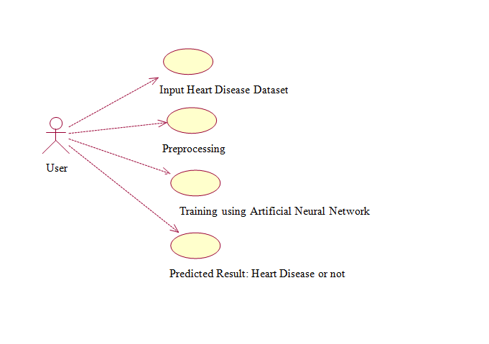

Fig No. 3.3.1 Use Case Diagram

CLASS DIAGRAM:

In software engineering, a class diagram in the Unified Modeling Language (UML) is a type of static structure diagram that describes the structure of a system by showing the system's classes, their attributes, operations (or methods), and the relationships among the classes. It explains which class contains information.
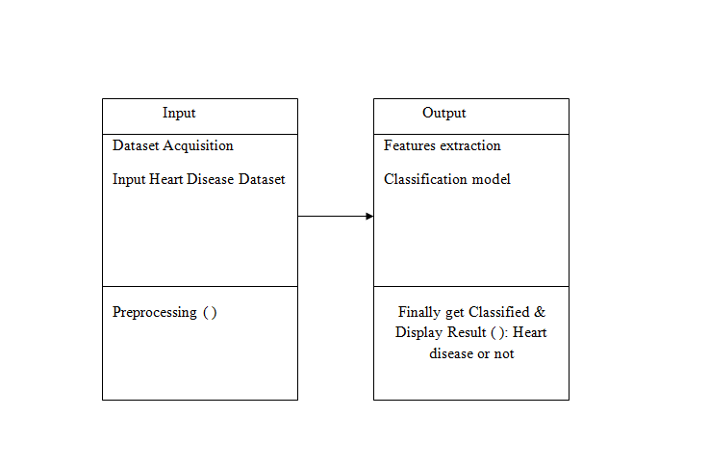
Fig No:4.3.2 Class Diagram
SEQUENCE DIAGRAM:

A sequence diagram in Unified Modeling Language (UML) is a kind of interaction diagram that shows how processes operate with one another and in what order. It is a construct of a Message Sequence Chart. Sequence diagrams are sometimes called event diagrams, event scenarios, and timing diagrams.
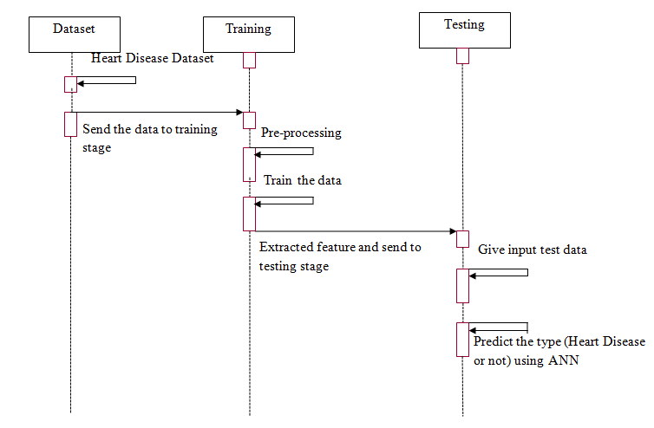

Fig No:4.3.3 Sequence Diagram

ACTIVITY DIAGRAM:

Activity diagrams are graphical representations of workflows of stepwise activities and actions with support for choice, iteration and concurrency. In the Unified Modeling Language, activity diagrams can be used to describe the business and operational step-by-step workflows of components in a system. An activity diagram shows the overall flow of control.

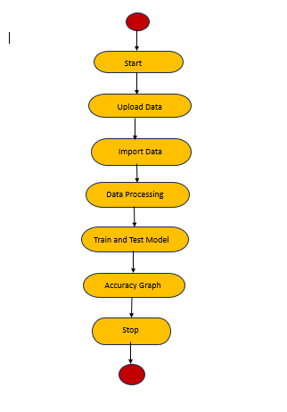

Fig No:4.3.4 Activity Diagram

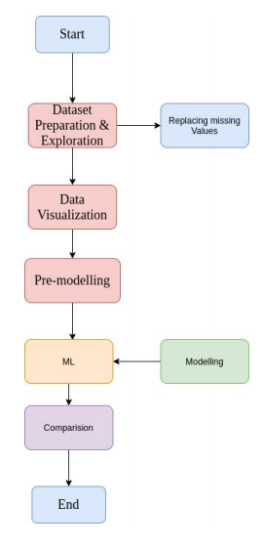
FLOW CHART

communication diagram
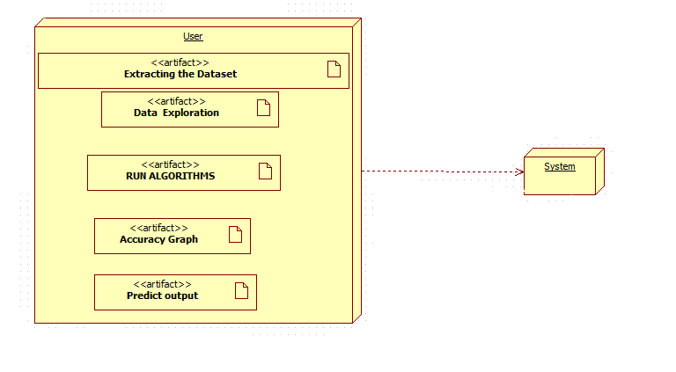
Activity diagram
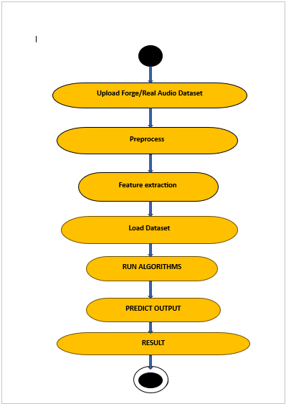

DEPLOYMENT DIAGRAM:

The deployment diagram captures the configuration of the runtime elements of the application. This diagram is by far most useful when a system is built and ready to be deployed.

COLLABRAION DIAGRAM
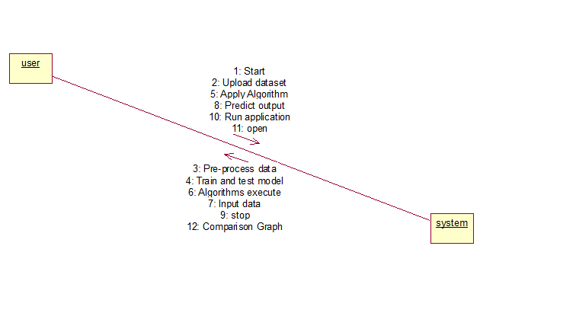

CHAPTER 4
SYSTEM IMPLEMENTATION

Chapter: 4 SYSTEM IMPLEMENTATION

4.1 SOFTWARE ENVIRONMENT

4.1.1 Python:

What is Python :-

Below are some facts about Python.

Python is currently the most widely used multi-purpose, high-level programming language.

Python allows programming in Object-Oriented and Procedural paradigms. Python programs generally are smaller than other programming languages like Java.

Programmers have to type relatively less and indentation requirement of the language, makes them readable all the time.

Python language is being used by almost all tech-giant companies like – Google, Amazon, Facebook, Instagram, Dropbox, Uber… etc.

The biggest strength of Python is huge collection of standard library which can be used for the following –
  - Machine Learning
  - GUI Applications (like Kivy, Tkinter, PyQt etc. )
  - Web frameworks like Django (used by YouTube, Instagram, Dropbox)
  - Image processing (like OpenCV, Pillow)
  - Web scraping (like Scrapy, BeautifulSoup, Selenium)
  - Test frameworks
  - Multimedia

Advantages of Python :-

Let’s see how Python dominates over other languages.

1. Extensive Libraries

Python downloads with an extensive library and it contain code for various purposes like regular expressions, documentation-generation, unit-testing, web browsers, threading, databases, CGI, email, image manipulation, and more. So, we don’t have to write the complete code for that manually.

2. Extensible

As we have seen earlier, Python can be extended to other languages. You can write some of your code in languages like C++ or C. This comes in handy, especially in projects.

3. Embeddable

Complimentary to extensibility, Python is embeddable as well. You can put your Python code in your source code of a different language, like C++. This lets us add scripting capabilities to our code in the other language.

4. Improved Productivity

The language’s simplicity and extensive libraries render programmers more productive than languages like Java and C++ do. Also, the fact that you need to write less and get more things done.

5. IOT Opportunities

Since Python forms the basis of new platforms like Raspberry Pi, it finds the future bright for the Internet Of Things. This is a way to connect the language with the real world.

6. Simple and Easy

When working with Java, you may have to create a class to print ‘Hello World’. But in Python, just a print statement will do. It is also quite easy to learn, understand, and code. This is why when people pick up Python, they have a hard time adjusting to other more verbose languages like Java.

7. Readable

Because it is not such a verbose language, reading Python is much like reading English. This is the reason why it is so easy to learn, understand, and code. It also does not need curly braces to define blocks, and indentation is mandatory. This further aids the readability of the code.

8. Object-Oriented

This language supports both the procedural and object-oriented programming paradigms. While functions help us with code reusability, classes and objects let us model the real world. A class allows the encapsulation of data and functions into one.

9. Free and Open-Source

Like we said earlier, Python is freely available. But not only can you download Python for free, but you can also download its source code, make changes to it, and even distribute it. It downloads with an extensive collection of libraries to help you with your tasks.

10. Portable

When you code your project in a language like C++, you may need to make some changes to it if you want to run it on another platform. But it isn’t the same with Python. Here, you need to code only once, and you can run it anywhere. This is called Write Once Run Anywhere (WORA). However, you need to be careful enough not to include any system-dependent features.

11. Interpreted

Lastly, we will say that it is an interpreted language. Since statements are executed one by one, debugging is easier than in compiled languages.

Any doubts till now in the advantages of Python? Mention in the comment section.

Advantages of Python Over Other Languages

1. Less Coding

Almost all of the tasks done in Python requires less coding when the same task is done in other languages. Python also has an awesome standard library support, so you don’t have to search for any third-party libraries to get your job done. This is the reason that many people suggest learning Python to beginners.

2. Affordable

Python is free therefore individuals, small companies or big organizations can leverage the free available resources to build applications. Python is popular and widely used so it gives you better community support.

3. Python is for Everyone

Python code can run on any machine whether it is Linux, Mac or Windows. Programmers need to learn different languages for different jobs but with Python, you can professionally build web apps, perform data analysis and machine learning, automate things, do web scraping and also build games and powerful visualizations. It is an all-rounder programming language.

Disadvantages of Python

So far, we’ve seen why Python is a great choice for your project. But if you choose it, you should be aware of its consequences as well. Let’s now see the downsides of choosing Python over another language.

1. Speed Limitations

We have seen that Python code is executed line by line. But since Python is interpreted, it often results in slow execution. This, however, isn’t a problem unless speed is a focal point for the project. In other words, unless high speed is a requirement, the benefits offered by Python are enough to distract us from its speed limitations.

2. Weak in Mobile Computing and Browsers

While it serves as an excellent server-side language, Python is much rarely seen on the client-side. Besides that, it is rarely ever used to implement smartphone-based applications. One such application is called Carbonnelle.

The reason it is not so famous despite the existence of Brython is that it isn’t that secure.

3. Design Restrictions

As you know, Python is dynamically-typed. This means that you don’t need to declare the type of variable while writing the code. It uses duck-typing. But wait, what’s that? Well, it just means that if it looks like a duck, it must be a duck. While this is easy on the programmers during coding, it can raise run-time errors.

4. Underdeveloped Database Access Layers

Compared to more widely used technologies like JDBC (Java Database Connectivity) and ODBC (Open Database Connectivity), Python’s database access layers are a bit underdeveloped. Consequently, it is less applied in huge enterprises.

5. Simple

No, we’re not kidding. Python’s simplicity can indeed be a problem. Take my example. I don’t do Java, I’m more of a Python person. To me, its syntax is so simple that the verbosity of Java code seems unnecessary.

This was all about the Advantages and Disadvantages of Python Programming Language.

History of Python : -

The programming language ABC, developed in the Netherlands, had a profound influence on the design of Python. Guido van Rossum, Python's creator, worked on the ABC project at CWI (Centrum Wiskunde & Informatica) in the 1980s. He drew upon his experience with ABC to design a simple scripting language that retained its better properties while avoiding its problems. As a result, Python inherited key features from ABC, including indentation for statement grouping, a simple syntax, and powerful data types such as hash tables, lists, strings, and numbers. By building upon the lessons learned from ABC, Guido van Rossum was able to create a language that has become a cornerstone of modern programming.

What is Machine Learning : -

Machine learning is a subfield of artificial intelligence that involves building mathematical models to understand and make predictions from data. At its core, machine learning is about creating models with tunable parameters that can be adapted to observed data, allowing the program to "learn" from the data. This learned model can then be used to make predictions, classify new data, or provide insights into the underlying patterns and relationships. Understanding the problem setting and categorizing approaches is essential to using machine learning tools effectively and achieving meaningful results

.

Categories Of Machine Leaning :-

Machine learning can be categorized into two main types: supervised and unsupervised learning. Supervised learning involves modeling the relationship between data features and labels, and is further divided into classification and regression tasks. Unsupervised learning involves modeling data features without labels, and includes tasks such as clustering and dimensionality reduction.

The need for machine learning arises from the need to make decisions based on data with efficiency and scale. Human intelligence is limited in solving complex problems at a large scale, and machine learning provides a way to automate decision-making processes using data-driven insights.
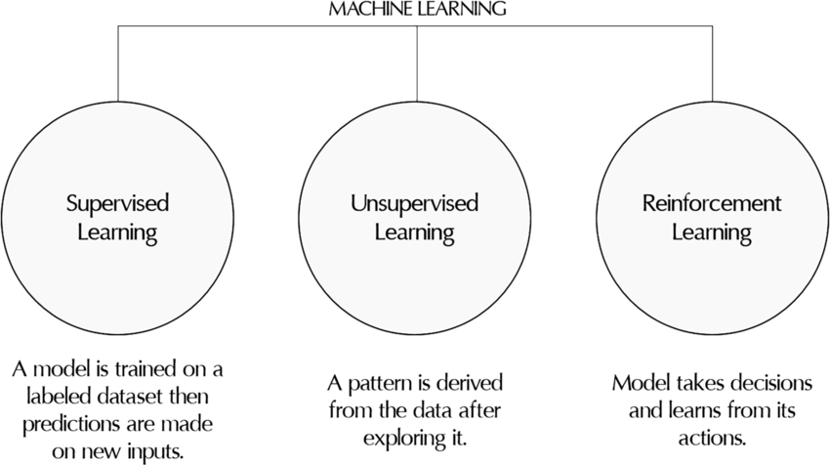

Challenges in Machines Learning :-

Machine Learning (ML) faces several challenges that hinder its progress. Some of the key challenges include:
- Poor data quality, leading to preprocessing and feature extraction issues
- Time-consuming tasks, such as data acquisition and feature extraction
- Limited availability of expert resources
- Lack of clear objectives for business problems
- Overfitting and underfitting issues
- Curse of dimensionality (too many features)
- Difficulty in deploying complex ML models in real-life scenarios.

Applications of Machines Learning :-

Machine Learning is the most rapidly growing technology and according to researchers we are in the golden year of AI and ML. It is used to solve many real-world complex problems which cannot be solved with traditional approach. Following are some real-world applications of ML −
- Emotion analysis
- Sentiment analysis
- Error detection and prevention
- Weather forecasting and prediction
- Stock market analysis and forecasting
- Speech synthesis
- Speech recognition
- Customer segmentation
- Object recognition
- Fraud detection
- Fraud prevention
- Recommendation of products to customer in online shopping

Advantages of Machine learning :-

1. Identifies trends and patterns: ML reviews large data volumes to discover specific trends and patterns.

2. Automation: ML enables machines to learn, make predictions, and improve algorithms without human intervention.

3. Continuous improvement: ML algorithms gain experience, improving accuracy and efficiency over time.

4. Handles complex data: ML algorithms can handle multi-dimensional and multi-variety data in dynamic environments.

5. Wide applications: ML has various applications across industries, enabling personalized experiences and targeted customer engagement.

Disadvantages of Machine Learning :-

1. Data Acquisition: ML requires large, unbiased, and high-quality datasets, which can be time-consuming to obtain.

2. Time and Resources: ML needs sufficient time and computational resources to train algorithms and achieve accurate results.

3. Interpretation of Results: Accurately interpreting ML results and choosing the right algorithms can be a significant challenge.

4. Error Susceptibility: ML is prone to errors, particularly when trained on biased or small datasets, leading to inaccurate predictions and potential undetected issues.

4.2 Create a Project

1. Project Overview
- Objective: To develop a predictive model using an Artificial Neural Network (ANN) to predict the likelihood of heart disease in patients based on various medical and lifestyle factors.
- Dataset: The model will be trained on the Heart Disease dataset, which contains features such as age, sex, blood pressure, cholesterol levels, etc.

2. Tools & Technologies
- Programming Language: Python
- Libraries:
  - Data processing: Pandas, NumPy
  - Data visualization: Matplotlib, Seaborn
  - Model building: TensorFlow or Keras, Scikit-learn
- Environment: Jupyter Notebook or any Python IDE (e.g., PyCharm, VS Code)

3. Steps to Implement the Project
- Data Collection:

Obtain the Heart Disease dataset, such as the Cleveland Heart Disease dataset, from the UCI Machine Learning Repository.

- Data Preprocessing:
- Load the Data: Use Pandas to load the dataset into a DataFrame.
- Handle Missing Values: Check for and handle any missing data, either by removing the rows or imputing the missing values.
- Data Normalization: Normalize the data to ensure that each feature contributes equally to the model.
- Feature Selection: Identify and select the most important features that contribute to heart disease prediction.
- Exploratory Data Analysis (EDA):
  - Visualize the Data: Create visualizations to understand the distribution of the data and the relationships between features.
  - Correlation Analysis: Analyze the correlation between features to identify highly correlated pairs.
- Model Building:
  - Define the ANN Architecture:
    - Input Layer: Number of neurons equal to the number of features.
    - Hidden Layers: One or more hidden layers with a varying number of neurons.
    - Output Layer: A single neuron with a sigmoid activation function (for binary classification).
  - Compile the Model:
    - Loss Function: Binary Crossentropy.
    - Optimizer: Adam or any other suitable optimizer.
    - Metrics: Accuracy.
  - Train the Model:
    - Split the dataset into training and test sets.
    - Fit the model on the training data and validate it on the test data.
    - Use techniques like early stopping to prevent overfitting.
- Model Evaluation:
  - Evaluate Model Performance: Use metrics such as accuracy, precision, recall, F1-score, and ROC-AUC score.
  - Confusion Matrix: Generate and interpret a confusion matrix to understand the classification performance.
- Model Tuning:
  - Hyperparameter Tuning: Optimize the model by tuning parameters such as the number of layers, number of neurons, learning rate, etc., using Grid Search or Random Search.
  - Cross-Validation: Perform cross-validation to ensure the model generalizes well to unseen data.
- Deployment:
  - Save the Model: Save the trained ANN model using a format such as HDF5.
  - Create a Flask API (Optional): Deploy the model as a web service using Flask for integration with web applications.
  - User Interface (Optional): Build a simple web interface to input patient data and display predictions.
- Documentation & Reporting:
  - Project Report: Document the entire process, including the problem statement, methodology, model evaluation, and conclusions.
  - Code Documentation: Ensure that the code is well-commented and organized for future reference.

4. Expected Outcomes
- A predictive model capable of accurately identifying the likelihood of heart disease based on patient data.
- A comprehensive understanding of how ANN can be used in the healthcare domain for predictive analytics.
- Potential deployment of the model as a tool for healthcare professionals or integration into healthcare management systems.

5. Extensions and Future Work
- Improvement with More Data: Improve model accuracy by training it on a larger and more diverse dataset.
- Integration with EHR: Consider integrating the model with Electronic Health Records (EHR) systems for real-time predictions.
- Exploration of Other Models: Compare the performance of the ANN model with other machine learning models such as Random Forests, Support Vector Machines, or more advanced deep learning architectures.

4.3 SOURCE CODE:

<!DOCTYPE html>

<html lang="en">

<head>

<meta charset="UTF-8">

<meta name="description" content="">

<meta http-equiv="X-UA-Compatible" content="IE=edge">

<meta name="viewport" content="width=device-width, initial-scale=1, shrink-to-fit=no">

<!-- The above 4 meta tags *must* come first in the head; any other head content must come *after* these tags -->

<!-- Title -->

<title> Heart Disease Prediction</title>

<!-- Favicon -->

<link rel="icon" href="img/core-img/favicon.ico">

<!-- Style CSS -->

<link rel="stylesheet" href="../static/style.css">

</head>

<body>

<!-- Preloader -->

<div id="preloader">

<div class="medilife-load"></div>

</div>

<!-- ***** Header Area Start ***** -->

<header class="header-area">

<!-- Top Header Area -->

<!-- Main Header Area -->

<div class="main-header-area" id="stickyHeader">

<div class="container h-100">

<div class="row h-100 align-items-center">

<div class="col-12 h-100">

<div class="main-menu h-100">

<nav class="navbar h-100 navbar-expand-lg">

<!-- Logo Area -->

<a class="navbar-brand" href="index.html"><img src="../static/img/core-img/logo.png" alt="Logo"></a>

<button class="navbar-toggler" type="button" data-toggle="collapse" data-target="#medilifeMenu" aria-controls="medilifeMenu" aria-expanded="false" aria-label="Toggle navigation"><span class="navbar-toggler-icon"></span></button>

<div class="collapse navbar-collapse" id="medilifeMenu">

<!-- Menu Area -->

<ul class="navbar-nav ml-auto">

<li class="nav-item ">

<a class="nav-link" href="{{url_for('index')}}">Home</a>

</li>

<li class="nav-item active">

<a class="nav-link" href="{{url_for('login')}}">Login</a>

</li>

<li class="nav-item">

<a class="nav-link" href="{{url_for('upload')}}">Upload</a>

</li>

</ul>

<!-- Appointment Button -->

</div>

</nav>

</div>

</div>

</div>

</div>

</div>

</header>

<!-- ***** Header Area End ***** -->

<!-- ***** Breadcumb Area Start ***** -->

<section class="breadcumb-area bg-img gradient-background-overlay" style="background-image: url(../static/img/bg-img/breadcumb2.jpg);">

<div class="container h-100">

<div class="row h-100 align-items-center">

<div class="col-12">

<div class="breadcumb-content">

<h3 class="breadcumb-title">Login</h3>

<p>Heart Disease Prediction </p>

</div>

</div>

</div>

</div>

</section>

<!-- ***** Breadcumb Area End ***** -->

<!-- ***** Blog Area Start ***** -->

</br>

</br>

</br>

</br>

<div class="container">

<div class="col-12">

<div class="section-heading">

<h2>Login</h2>

</div>

</div>

<head>

<style>

body { background-image: url("../static/images/email3.jpg"); }

</style>

<script>

addEventListener("load", function () {

setTimeout(hideURLbar, 0);

}, false);

function hideURLbar() {

window.scrollTo(0, 1);

}

function login(){

var uname = document.getElementById("uname").value;

var pwd = document.getElementById("pwd").value

if(uname == "admin" && pwd == "admin")

{

alert("Login Success!");

window.location = "{{url_for('upload')}}";

return false;

}

else

{

alert("Invalid Credentials!")

}

}

</script>

</head>

<body id="page-top">

<!-- Portfolio Section -->

<section class="page-section portfolio" id="portfolio">

<br>

<br>

<!-- Portfolio Section Heading -->

<!-- Icon Divider -->

<!-- Portfolio Grid Items -->

<div class="row">

<!-- Portfolio Item 1 -->

<div class="col-md-6 col-lg-4" style="margin-left:380px">

<div class="control-group">

<!-- Username -->

<label class="control-label" for="username"><b>Username</b></label>

<div class="controls">

<input type="text" id="uname" name="uname" placeholder="" class="form-control">

</div>

</div>

<div class="control-group">

<!-- Password--> <br>

<label class="control-label" for="password"><b>Password</b></label>

<div class="controls">

<input type="password" id="pwd" name="pwd" placeholder="" class="form-control">

</div>

</div>

<div class="col-md-6 col-lg-4" style="margin-left:-150px">

<div class="control-group">

<!-- Button -->

<br>

<div class="controls">

<input type="button" class="btn btn-success" value="Login" style="margin-left: 270px" onclick="login()">

</div>

</div>

</div>

</div>

</div>

</section>

</body>

</div>

</br>

</br>

<footer class="footer-area section-padding-100">

<!-- Main Footer Area -->

<div class="main-footer-area">

<div class="container-fluid">

<div class="row">

<div class="col-12 col-sm-6 col-xl-3">

</div>

<div class="col-12 col-sm-6 col-xl-3">

</div>

<div class="col-12 col-sm-6 col-xl-3">

<div class="footer-widget-area">

<div class="widget-title">

</div>

</div>

</div>

<div class="col-12 col-sm-6 col-xl-3">

<div class="footer-widget-area">

<div class="widget-title">

</div>

<div class="footer-newsletter-area">

</div>

</div>

</div>

</div>

</div>

</div>

<!-- Bottom Footer Area -->

<div class="bottom-footer-area">

<div class="container-fluid">

<div class="row">

<div class="col-12">

</div>

</div>

</div>

</div>

</footer>

<!-- ***** Blog Area End ***** -->

<!-- ***** Footer Area Start ***** -->

<!-- ***** Footer Area End ***** -->

<!-- jQuery (Necessary for All JavaScript Plugins) -->

<script src="../static/js/jquery/jquery-2.2.4.min.js"></script>

<!-- Popper js -->

<script src="../static/js/popper.min.js"></script>

<!-- Bootstrap js -->

<script src="../static/js/bootstrap.min.js"></script>

<!-- Plugins js -->

<script src="../static/js/plugins.js"></script>

<!-- Active js -->

<script src="../static/js/active.js"></script>

</body>

</html> import tensorflow as tf

from tensorflow.keras.models import Sequential,load_model,model_from_json

from tensorflow.keras.layers import Dense, Dropout,Activation,MaxPooling2D,Conv2D,Flatten

from tensorflow.keras.applications.imagenet_utils import preprocess_input, decode_predictions

from tensorflow.keras.preprocessing.image import load_img

from tensorflow.keras.preprocessing import image

import numpy as np

import h5py

import os

import sys

import json

from sklearn.preprocessing import StandardScaler

from predictor import sc

import pandas as pd

# Flask utils

from flask import Flask, redirect, url_for, request, render_template

from werkzeug.utils import secure_filename

# Define a flask app

app = Flask(__name__)

with open('heart_diseases.json','r') as f:

model = model_from_json(f.read())

# Load your trained model

model.load_weights('heart_diseases.h5')

@app.route('/')

@app.route('/index')

def index():

return render_template('index.html')

@app.route('/chart')

def chart():

return render_template('chart.html')

#@app.route('/future')

#def future():

# return render_template('future.html')

@app.route('/login')

def login():

return render_template('login.html')

@app.route('/upload')

def upload():

return render_template('upload.html')

@app.route('/preview',methods=["POST"])

def preview():

if request.method == 'POST':

dataset = request.files['datasetfile']

df = pd.read_csv(dataset,encoding = 'unicode_escape')

df.set_index('Id', inplace=True)

return render_template("preview.html",df_view = df)

@app.route('/prediction', methods = ['GET', 'POST'])

def prediction():

# Main page

return render_template('prediction.html')

@app.route('/predict',methods=['POST'])

def predict():

int_feature = [x for x in request.form.values()]

print(int_feature)

# Make Prediction

prediction = model.predict(sc.transform(np.array([int_feature])))

print(prediction)

# Process your result for human

if prediction > 0.5:

result = "Heart diseases"

else:

result = "No diseases"

return render_template('prediction.html', prediction_value=result)

@app.route('/performance')

def performance():

return render_template('performance.html')

if __name__ == '__main__':

app.run()

4.4 OUTPUT SCREENS



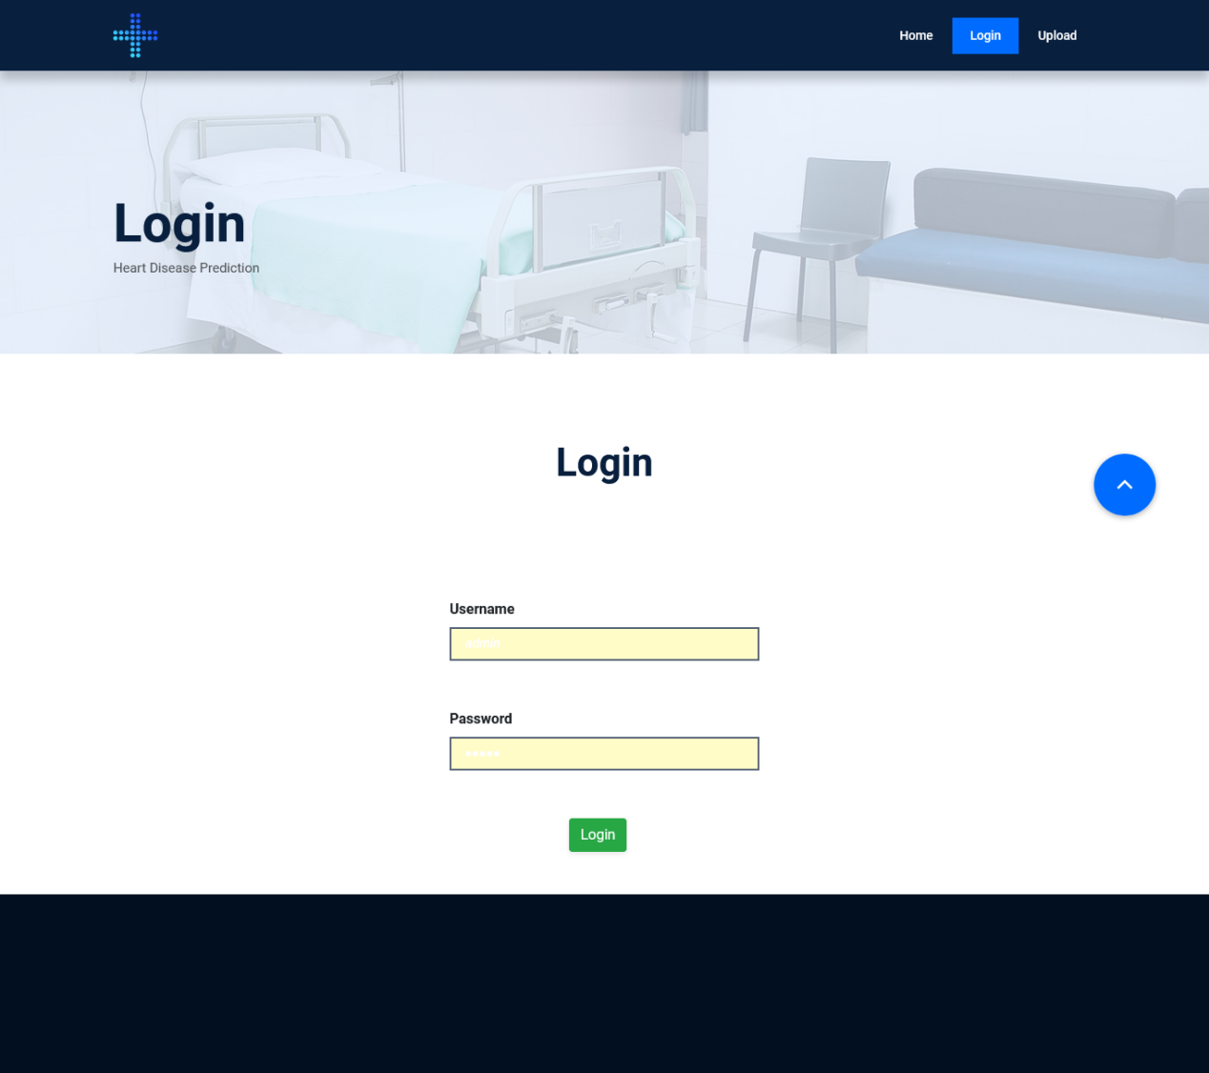
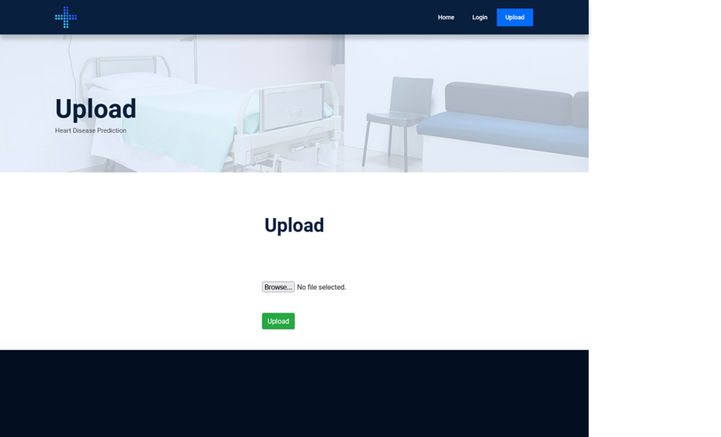

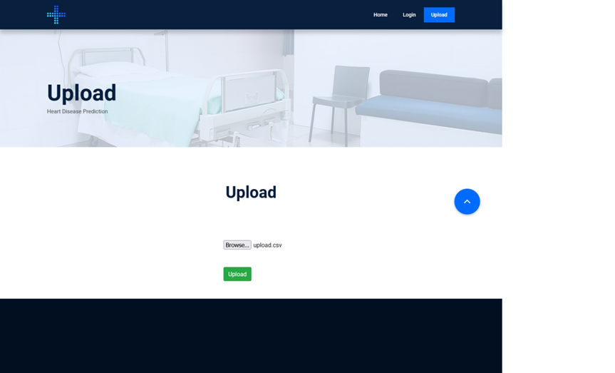
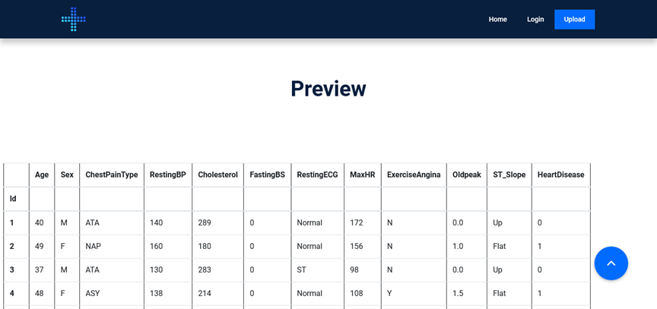

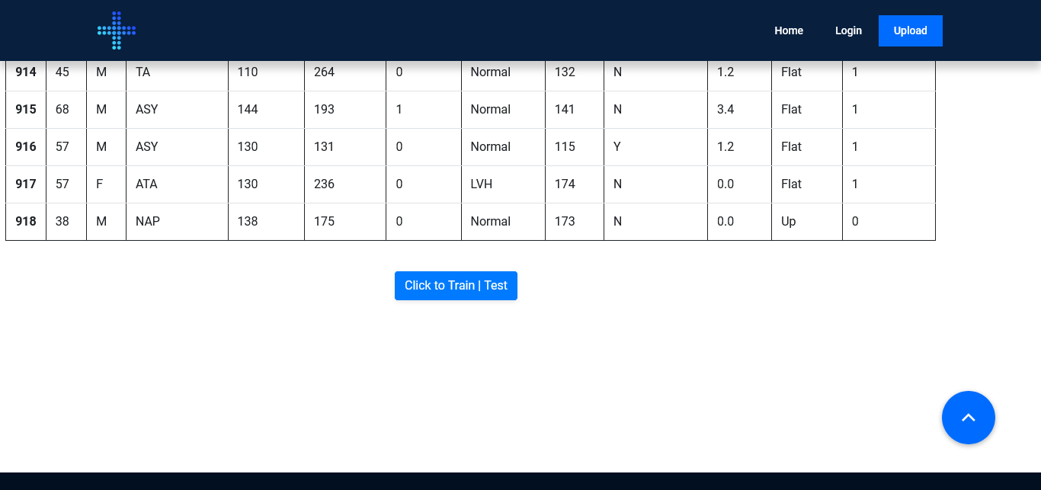
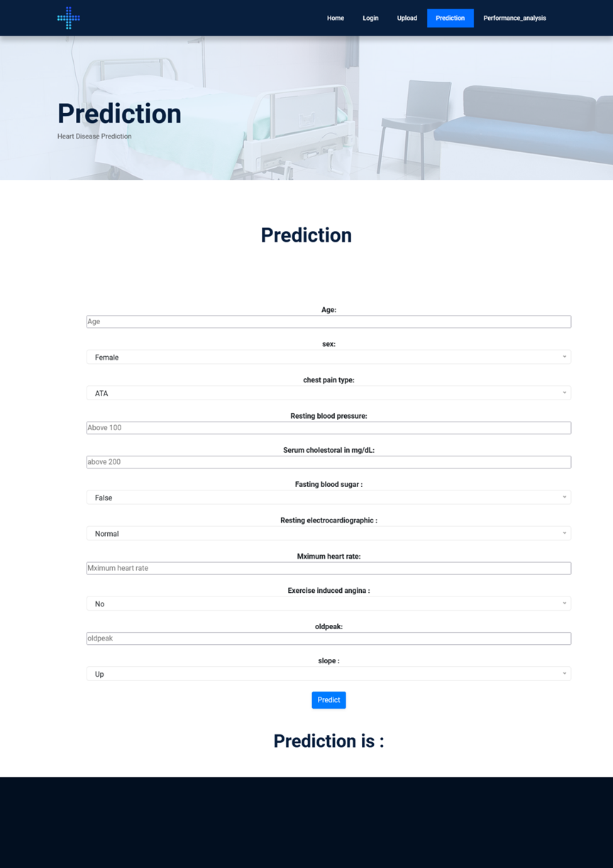
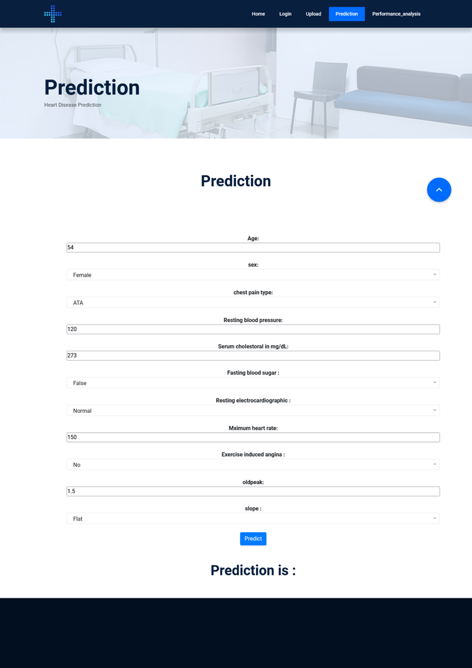

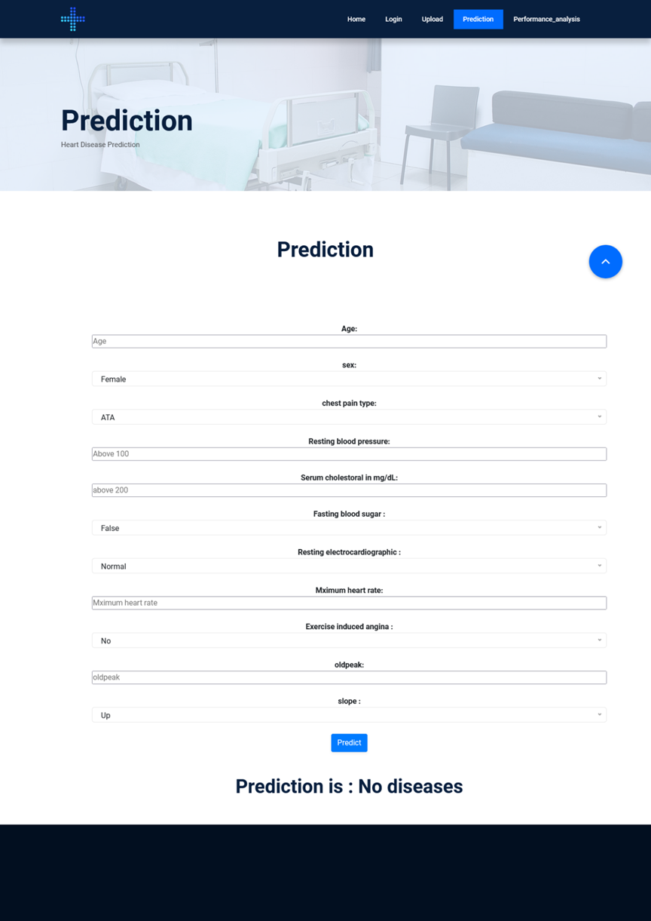

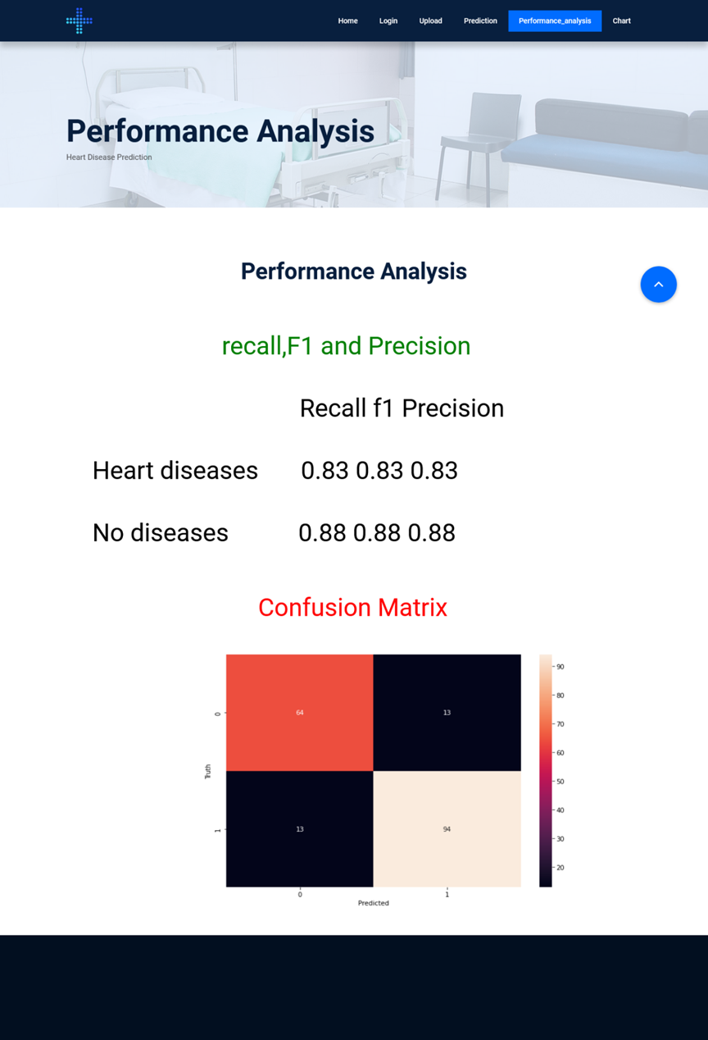
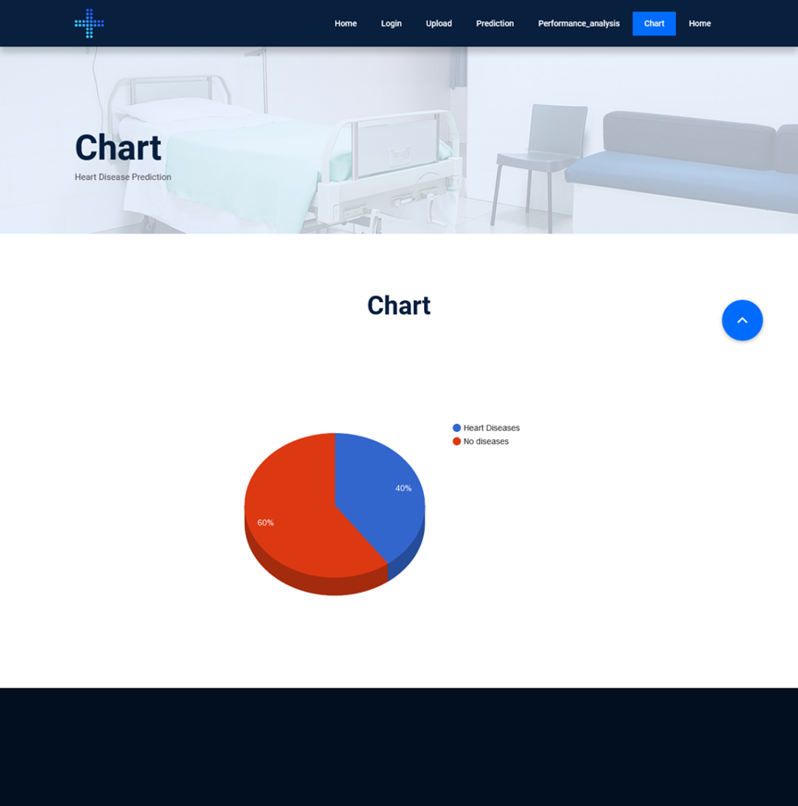

CHAPTER 5
SYSTEM TESTING
SYSTEM TESTING
Chapter: 5
The purpose of testing is to discover errors. Testing is the process of trying to discover every conceivable fault or weakness in a work product. It provides a way to check the functionality of components, sub- assemblies, assemblies and/or a finished product It is the process of exercising software with the intent of ensuring that the Software system meets its requirements and user expectations and does not fail in an unacceptable manner. There are various types of test. Each test type addresses a specific testing requirement.
5.1 TYPES OF TESTS:
Unit testing
Unit testing involves the design of test cases that validate that the internal program logic is functioning properly, and that program inputs produce valid outputs. All decision branches and internal code flow should be validated. It is the testing of individual software units of the application .it is done after the completion of an individual unit before integration. This is a structural testing, that relies on knowledge of its construction and is invasive. Unit tests perform basic tests at component level and test a specific business process, application, and/or system configuration. Unit tests ensure that each unique path of a business process performs accurately to the documented specifications and contains clearly defined inputs and expected results.
Integration testing
Integration tests are designed to test integrated software components to determine if they actually run as one program. Testing is event driven and is more concerned with the basic outcome of screens or fields. Integration tests demonstrate that although the components were individually satisfaction, as shown by successfully unit testing, the combination of components is correct and consistent. Integration testing is specifically aimed at exposing the problems that arise from the combination of components.

Functional test
Functional tests provide systematic demonstrations that functions tested are available as specified by the business and technical requirements, system documentation, and user manuals.
Functional testing is centered on the following items:
Valid Input : identified classes of valid input must be accepted.
Invalid Input : identified classes of invalid input must be rejected.
Functions : identified functions must be exercised.
Output : identified classes of application outputs must be exercised. Systems/Procedures : interfacing systems or procedures must be invoke
Organization and preparation of functional tests is focused on requirements, key functions, or special test cases. In addition, systematic coverage pertaining to identify Business process flows; data fields, predefined processes, and successive processes must be considered for testing. Before functional testing is complete, additional tests are identified and the effective value of current tests is determined.
System Test
System testing ensures that the entire integrated software system meets requirements. It tests a configuration to ensure known and predictable results. An example of system testing is the configuration oriented system integration test. System testing is based on process descriptions and flows, emphasizing pre-driven process links and integration points.
White Box Testing
White Box Testing is a testing in which in which the software tester has knowledge of the inner workings, structure and language of the software, or at least its purpose. It is purpose. It is used to test areas that cannot be reached from a black box level.
Black Box Testing
Black Box Testing is testing the software without any knowledge of the inner workings, structure or language of the module being tested. Black box tests, as most other kinds of tests, must be written from a definitive source document, such as specification or requirements document, such as specification or requirements document. It is a testing in which the software under test is treated, as a black box .you cannot “see” into it. The test provides inputs and responds to outputs without considering how the software works.
Unit Testing
Unit testing is usually conducted as part of a combined code and unit test phase of the software lifecycle, although it is not uncommon for coding and unit testing to be conducted as two distinct phases.
Test strategy and approach
Field testing will be performed manually and functional tests will be written in detail.
Test objectives
All field entries must work properly.
Pages must be activated from the identified link.
The entry screen, messages and responses must not be delayed.
Features to be tested
Verify that the entries are of the correct format No duplicate entries should be allowed
All links should take the user to the correct page.

CHAPTER 6
CONCLUSION

Chapter: 6 CONCLUSION

6.1 CONCLUSION

In conclusion, the project "Heart Disease Prediction using Artificial Neural Network (ANN)" demonstrates the potential of using machine learning techniques to accurately predict the likelihood of heart disease in patients. The project involved collecting a large dataset of patient information, preprocessing the data, and developing an ANN model that can learn from the data and accurately predict the likelihood of heart disease. The proposed system offers several advantages over existing methods, such as early detection of heart disease, high accuracy, scalability, and customizability. The system can be continuously improved by incorporating new data and updating the model as new information becomes available. The project involved several modules, including data collection, dataset preparation, importing necessary libraries, splitting the dataset, developing the ANN model, model selection, applying the model, and analyzing the results. The developed model achieved high accuracy and demonstrated its potential for accurately predicting the likelihood of heart disease in patients. Overall, the project highlights the potential of using machine learning techniques, specifically ANN, to accurately predict the likelihood of heart disease in patients. This system has the potential to aid healthcare professionals in early detection and treatment of heart disease, leading to improved patient outcomes and better management of healthcare resources

FUTURE ENHANCEMENT:

- Incorporating additional features: The current model uses a set of features to predict the likelihood of heart disease. However, new features may become available that could improve the accuracy of the model. For example, incorporating genetic data or wearable technology data could provide more comprehensive information for predicting the likelihood of heart disease.
- Using more advanced ANN models: The current model uses a basic ANN model with multiple hidden layers. More advanced ANN models such as convolutional neural networks (CNNs) or recurrent neural networks (RNNs) could be used to improve the accuracy of the model.
- Incorporating more data: The current model uses a relatively small dataset. Incorporating larger and more diverse datasets could improve the accuracy and robustness of the model.

1.Clinical Decision Support Systems:

Integration of deep learning-based stroke prediction models into clinical decision support systems to assist healthcare professionals in making informed decisions regarding patient care and treatment
strategies. This could improve patient outcomes and optimize healthcare resource allocation.

2.Longitudinal Studies and Population Health Management:

Conducting longitudinal studies to assess the long-term effectiveness and impact of deep learning-based stroke prediction models on population health management strategies. This could involve collaboration with public health agencies and healthcare providers to implement preventive interventions at scale.

CHAPTER 7

REFERENCES

Chapter: 7 REFERENCES

[1] Ayatollahi, H., Gholamhosseini, L., & Salehi, M. (2019). "Predicting coronary artery disease: a comparison between two data mining algorithms."

[2] BMC Public Health. doi: 10.1186/S12889-019-6721-5. Benjamin, H., David, F., & Belcy, S. A. (2018). "Heart disease prediction using data mining techniques." ICTACT Journal of Soft Computing, 9(1), 1824-1830

[3] Dengqing Zhang, Yunyi Chen, Yuxuan Chen, Shengyi Ye, Wenyu Cai, Junxue Jiang, Yechuan Xu, Gongfeng Zheng, Ming Chen, "Heart Disease Prediction Based on the Embedded Feature Selection Method and Deep Neural Network", Journal of Healthcare Engineering, vol. 2021, Article ID 6260022, 9 pages, 2021.

[4] Dulhare, U. N. (2018). "Prediction system for heart disease using naïve bayes and particle swarm optimisation." Biomedical Research, 29 (12), 2646-2649.

[5] Gawali, M., & Shirwalkar, N. (2018). "Heart disease prediction system using data mining techniques." International Journal of Pure and Applied mathematics, 120 (6), 499-506.

[6] Haq, A. U., Li, J.-P., Memon, M. H., Nazir, S., & Sun, R. (2018). "A hybrid intelligent system framework for the prediction of heart disease using machine learning algorithms." Hindawi Mobile Information System. Doi: 10.1155/2018/3860146.

[7] Khan, S. N., Nawi, N. M., Shahzad, A., Ullah, A., & Mushtaq, M. F. (2019). "Comparative analysis for heart disease prediction." International Journal on Informatics Visualization, 1 (4-2), 227-231.

[8] Nashif, S., Raiban, M., Islam, M., & Imam, M. H. (2018). "Heart disease detection by using machine learning algorithms and a real-time cardiovascular health monitoring system." World Journal of Engineering and Technology, 6, 854-873.

[9] Prasead, R., Anjali, P., Adil, S., & Deepa, N. (2019). "Heart disease prediction using logistic regression algorithm using machine learning." International Journel of Engineering and Advanced Technology, 8 (3S), 659-662.

[10] Salhi, Dhai Eddine & Tari, Abdelkamel & Kechadi, MTahar. (2021). "Using Machine Learning for Heart Disease Prediction." 10.1007/978-3-030-69418-0_7.

[11] Sharmila, S., & Gandhi, M. P. (2017). "Analysis of heart disease prediction using data mining techniques." International Journal of Advanced Networking and Applications, 8 (5), 93- 95.

[12] Sridhar, A., & Kapardhi, A. (2018). "Predicting heart disease using machine learning algorithms." International Research Journal of Engineering and technology, 6 (4), 36-38

